Project Overview and Problem Definition

Project Concept
Broad Challenge
- Living with chronic health conditions involves managing isolated clinical measurements and attending appointments.
- Symptoms, medication effects, functional limitations, lifestyle changes and daily fluctuations occur continuously, and may have significant relevance to management.
- Clinical encounters alone only capture brief snapshots of this experience.

Proposed Solution
A locally hosted AI-powered personal health diary that allows people living with chronic conditions to continuously record and organise relevant health information.

Potential/Current Functions:
- Accept natural-language daily health entries via various media (voice, text, images).
- Store symptoms, function, medication effects, lifestyle factors and other relevant observations longitudinally.
- Process uploaded health information and documents.
- Help identify patterns across time.
- Summarise information into clinically useful formats.
- Generate configurable reports tailored to different specialists or appointments.
- Retain the underlying source material, ensuring information remains traceable.
- Operate locally or within user-controlled storage to prioritise privacy and patient ownership.

Core Project Proposition
This Capstone Project investigates whether a patient-controlled AI system could help translate the continuous lived experience of chronic illness into structured information that is more useful during episodic healthcare encounters.

Living with Chronic Health Conditions
1.1 Chronic Conditions and Multimorbidity
Establish:
- Prevalence of chronic disease and multimorbidity within Australia.
- Increasing incidence and prevalence of chronic health conditions.
- Ongoing interaction between symptoms, treatment, lifestyle and healthcare.
- Difference between treating a disease and living with it.

Multimorbidity, defined as an individual living with two or more chronic health conditions, is becoming an increasingly common challenge within Australian healthcare. At the intersection of complex interplay between increasing life expectancy, lifestyle behaviours and socioeconomic disparities, multimorbidity is a strong predictor of all-cause mortality in people over 45 years of age (Kabir et al., 2022). Findings estimated 38% of all Australians were living with multimorbidity in 2022 (AIHW).

1.2 Clinical Severity Versus Lived Burden
Introduce the idea that clinical measures do not always capture how strongly a condition affects everyday life.

Potential dimensions to explore:
- Pain
- Fatigue
- Mobility and function
- Cognitive burden
- Medication effects
- Psychological impacts
- Disruption to work or social life
- Treatment burden

Potential incorporation of interview material where relevant.

Traditionally, disease-specific care has been the forefront of multimorbidity treatment. Prioritisation of clinical severity, where conditions with the greatest future mortality or morbidity risk take priority in care. However, this approach is met with a notable gap in treatment priorities between clinicians and patients. Sathanapally et al. 2020 investigated these priorities, finding clinicians place greater weight on long term risk, while patients emphasise current illness experience and future function. With this, patient-centred care has been increasingly valued and utilised within multimorbidity care. Through this, involvement of patients in the management of their care through perception of pain, fatigue, function, lived burden, disruption to work or social life and treatment burden are taken into account (Hardman et al., 2021). However, these patient-centric approaches can also place a new additional ___ burden (having to remember, track etc).

Central Problem Statement
Healthcare systems are generally structured around episodic clinical encounters, whereas chronic illness is experienced continuously.

Introduction draft (Freya)

More than half of all Australians now live with at least one chronic condition. In 2022, an estimated 15.4 million Australians (61%) were living with at least one long-term condition, and 38% had two or more (AIHW 2026). The impact on the health system is substantial: in 2023–24, chronic conditions were associated with 55% of all hospitalisations and $98.5 billion in health spending, and in 2024 they accounted for 84% of Australia’s total burden of disease (AIHW 2026).
We are seeing health care tackling the diagnoses and treatment of these conditions, however, we lack support for those that live with them. Living with a chronic disease is a multifaceted problem, consisting of fatigue, pain and medication consumption, all fluctuating during different periods. It highlights the need to focus on those living with it, helping them to manage it at home and ensuring that what happens between appointments is not lost when they next see a clinician.

This fault is exactly what our project targets. Healthcare is currently structured around episodic encounters, not taking a continuous approach for chronic patients. In a short consultation, patients must reconstruct weeks or months of symptoms, medication responses and test results from memory, and information can be scattered across different specialists, doctors or providers they are visiting. Existing tools lack depth and currently only partially help. Institutional records capture clinical events rather than lived experience, and self-tracking apps leave the work of organising information with the patient.

We have therefore, successfully created a patient managed AI system that translates symptoms, appointment notes and everything that comes with chronic illness into a single, more useful record. We built a prototype that allows for voice notes to be record, photos and documents to merge into one traceable record in storage, that is easily accessible bu the patient and their family or friends. It allows for the production of specific notes tailored to the individual, making their progress and symptoms easy to track

The Challenge: Loss of Longitudinal Context
2.1 Fragmented Healthcare
Explore how chronic-condition management may involve:
- GPs
- Specialists
- Hospitals
- Allied health
- Pathology
- Imaging
- Medications
- Self-management

Relevant information may therefore become distributed across different providers and systems.

2.2 The Consultation Snapshot
Short clinical appointments require patients to reconstruct:
- What has changed since their last appointment
- Symptom patterns.
- Medication responses
- Important events
- Previous investigations
- Functional changes

Creates a mismatch between the longitudinal nature of chronic illness and the episodic nature of clinical care, a significant burden for people living with chronic health conditions.

2.3 Patient Recall and Information Burden
Potential issues to investigate:
- Difficulty remembering symptom trajectories
- Difficulty deciding what information is clinically relevant
- Large quantities of pathology reports, specialist letters and medication information
- Repeated retelling
- Difficulting communicating changes precisely

2.4 Specialising for Specialists
Specialists require different subsets of a patient’s complete health history. How can a patient’s longitudinal health information be retained comprehensively while being selectively reorganised for the needs of a particular clinical encounter.

Existing Approaches and the Gap
3.1 Current Health Records
Consider:
- Electronic medical records.
- Patient portals
- My Health Record
- Specialist letters
- Pathology systems

Do these systems capture the patient’s lived experience between clinical encounters?

How accessible is health information currently?

3.2 Existing Self Tracking
Examples to investigate:
- Symptom diaries
- Medication trackers
- Wearable applications
- Mobile phone apps
- Notes/spreadsheets

What are some current limitations?
- Manual organisation
- Disease-specific design
- Information silos
- Difficult long-term interpretation
- Limited ability for data conversion.
- Health literacy gap.

3.3 Existing AI Health Tools
Investigate:
- AI symptom tracking
- Medical summarisation
- Conversational health assistants
- Personal health-record symptoms

Potential Gap Statement
Existing health technologies may either focus on institutional clinical records or isolated forms of patient self-tracking, leaving an opportunity for a patient-controlled system that continuously captures lived experience and translates it into structured longitudinal clinical context.

Design Principles
What does the solution need to achieve?

4.1 Patient Ownership
The patient retains control over the system:
- Raw information.
- Diary entries.
- Records.
- Generated summaries

4.2 Privacy
Local hosting aims to avoid unnecessarily transmitting sensitive health information to external AI services, and protects data from cloud compromises.

4.3 Low Friction Input
Recording information should be easy and accessible:
Potential inputs:
- Text.
- Voice notes
- Photographs
- PDFs
- Pathology results
- Wearable data
4.4 Traceability
Generated claims or summaries should ideally link back to their original source.

Example:
“Increasing fatigue reported over the previous three weeks” → links relevant entries.

4.5 Clinical Relevance
The system should not merely accumulate information.
It should help transform it:
- Raw patient experience.
- Organised longitudinal information.
- Clinically relevant summary.

Proposed Solution
5.1 System Overview
Describe the model as a locally hosted AI agent interacting with patient-controlled health record.

Potential Workflow:
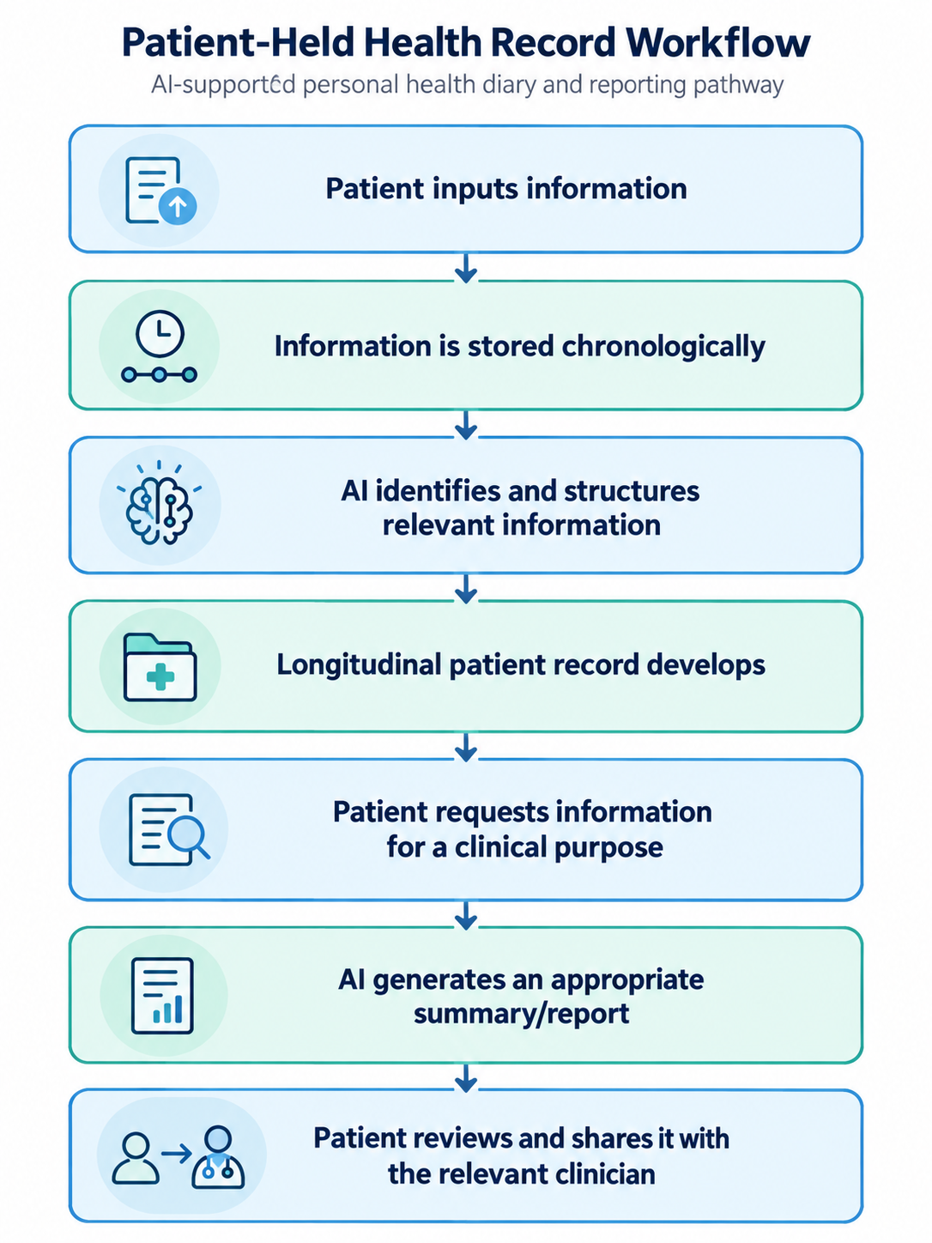

5.2 Everyday Health Diary
The patient records observations naturally:
- “My back pain was worse today after sitting for three hours. Took Panadol at 2 pm and it helped slightly”

The system could structure this into:
- Symptom: lower back pain.
- Severity: worsened.
- Context: prolonged sitting.
- Medication: paracetamol.
- Response: partial improvement.
- Date/time.

Avoids forcing patients to manually populate complex structured databases.

5.3 Document Processing
Potential inputs:
- Specialist letters.
- Pathology reports.
- Prescriptions.
- Discharge summaries.
- Imaging reports.
5.4 Longitudinal Health Record
Possible components:
- Current conditions.
- Medication list.
- Allergies.
- Symptom timeline.
- Investigations.
- Treatment changes.
- Functional status.
- Patient-defined concerns.
- Appointment history
- Reminder system.

5.5 Specialist-Specific Reporting
Major feature of the project is context based summaries. Rather than presenting every clinician with the entire dataset, summaries based on the purpose of appointments can be generated instead.

Example: Nephrology Report
- Recent eGFR/creatinine results.
- Patient recorded blood pressure records.
- Relevant medications.
- Fluid changes.
- Fatigue/cramping symptoms.

The underlying patient record remains the same; the presentation changes according to clinical relevance.

Development Methodology
6.1 Understanding the Problem
Relevant sources to branch from:
- Chronic-condition interviews.
- Academic literature.
- Healthcare system research.
- Lived-experience literature.
- Consultation with mentors.
- Group member’s disciplinary knowledge.

6.2 Identifying User Needs
Potential needs:
- Remembering changes.
- Reducing repetitive explanations.
- Organising documents and information.
- Tracking symptoms.
- Communicating with clinicians.
- Retaining ownership of information.

6.3 Concept Development
Document:
- Initial ideas.
- Competing solutions.
- Why the AI diary was selected.
- Features considered.
- Features rejected.
- Changes in project scope.

6.4 Prototype Development
Outline how the prototype evolved.
- Basic diary.
- Structured information extraction.
- Longitudinal timeline.
- Document processing.
- Specialist-specific summaries.
- Source traceability.
- local/private implementation.

Final Product and Demonstration
7.1 Example Patient Journey
Provide sample to visually demonstrate what the system actually does.
- Logging symptoms, medication effects, functional changes.
- Uploading pathology results or a specialist letter.
- Prior to appointment, inquire for summary generation.

Evaluation
Distinguish between what the prototype can demonstrate and what would require future clinical testing.

8.1 Technical Evaluation
- Can the model extract relevant information accurately?
- Can it maintain information longitudinally?
- Can it distinguish relevant versus irrelevant information?
- Can it generate different context-based summaries?

8.2 Usability
- Is entering information easy?
- Is the output understandable?
- Can users correct information?
- Can users control what is shared?

8.3 Clinical Application
Key criteria:
- Relevance.
- Conciseness.
- Completeness.
- Accuracy.
- Traceability.
- Usefulness for preparing consultations.

8.4 Safety
The system is intended primarily to support organisation, recall and communication rather than independently diagnose or replace clinicians.

- Hallucinated information.
- Incorrect interpretation.
- Over-reliance on AI.
- Omission of important information.
- Outdated records.
- Inappropriate medical advice.

Privacy, Ethics and Governance
Probably a significant section.

Key points of discussion:
- Sensitivity of health information.
- Relevant law, health system protocol.
- Local hosting.
- Patient ownership.
- Consent.
- Data security.
- Sharing controls.
- AI transparency.
- Ability to inspect source information.
- Correction of errors.
- Clinician responsibly versus AI output.

Tie back to key design principles.

Potential Impact
10.1 Patients
- Improved recall
- Stronger sense of ownership.
- Reduced organisational burden.
- Better preparation for appointments.
- Clearer longitudinal understanding of their own health.

10.2 Clinicians
- More organised histories.
- Easier identification of longitudinal patterns.
- Relevant information before consultations.
- Reduced time spent reconstructing patient history.

Limitations

Potential points:
AI related:
- Hallucination.
- Extraction errors.
- Contextual misunderstanding.
- Model limitations.

User related:
- Incomplete inputs.
- Inconsistent diary usage.
- Digital literacy.
- Information overload.

Clinical
- Clinician trust.
- Report relevance.
- Integration with workflow.
- Liability.

Technical
- Computational requirements (RAM etc).
- Local installation.
- Interoperability.
- wearable/device compatibility.

Research
- Prototype rather than validated clinical intervention.
- Limited user testing.
- Small-scale evaluation.

Future Directions
Immediate
- Refine prototype.
- User testing.

Medium-term
- Clinical evaluation.
- Integration with wearables.
- Larger patient testing.

Longer-term
- Formal clinical evaluation.
- Interoperability with current healthcare systems.
- Evaluation of consultation efficiency.
- Evaluation of patient-reported outcomes.

